1. Select * from transaksi ORDER BY id_username

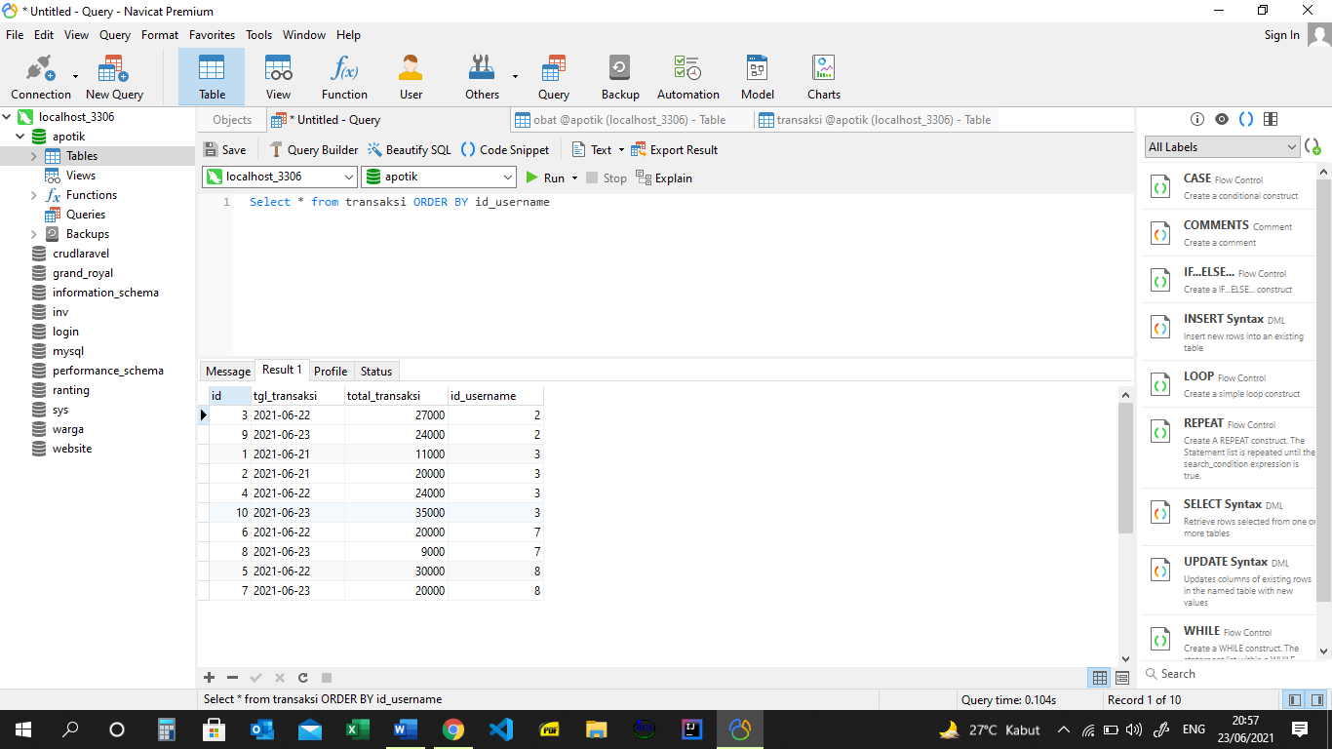

2. Select * from transaksi ORDER BY id_username DESC

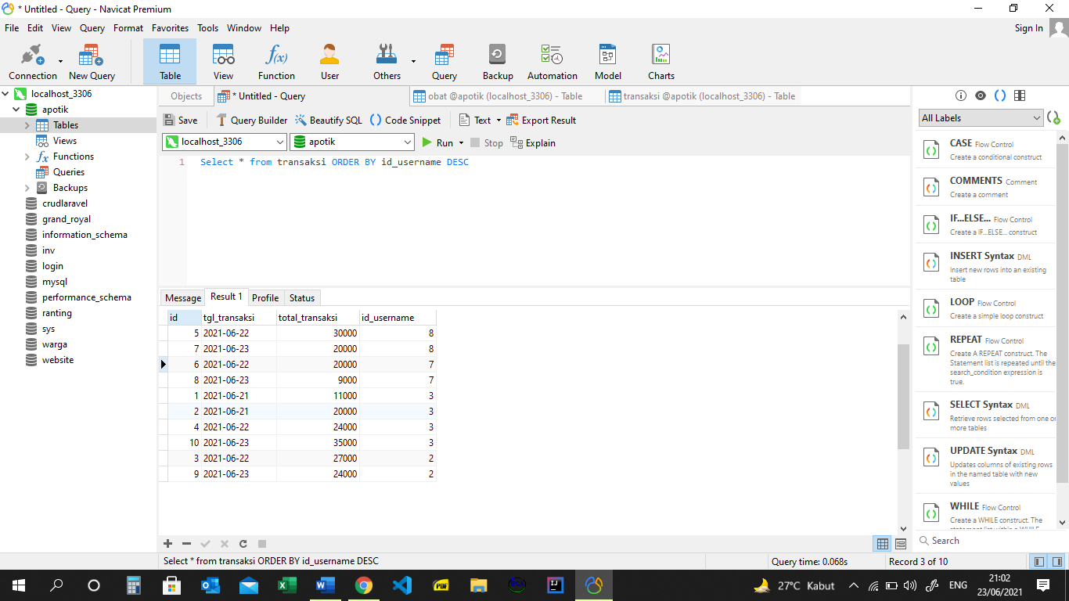

3. SELECT nama_karyawan, alamat FROM karyawan WHERE alamat LIKE "%Tangerang%"

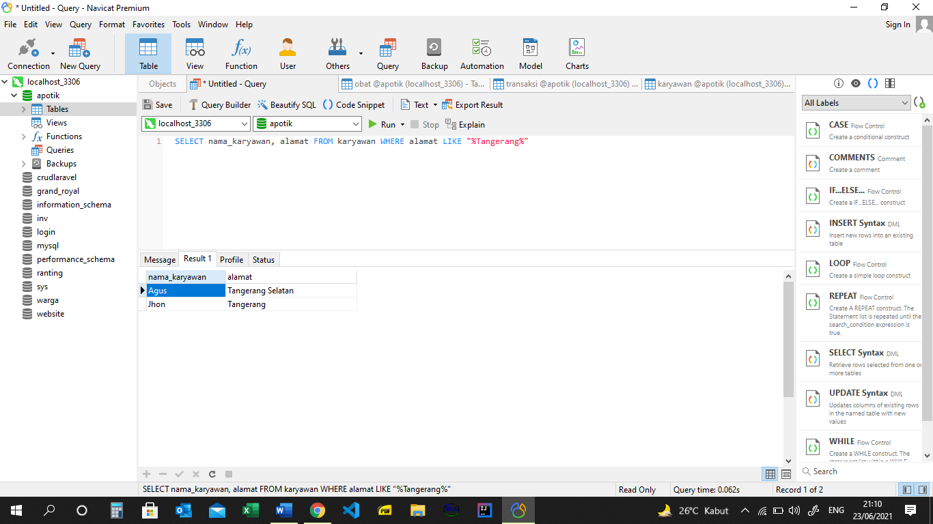

4. Select tgl_transaksi, SUM(total_transaksi) from transaksi GROUP BY tgl_transaksi DESC

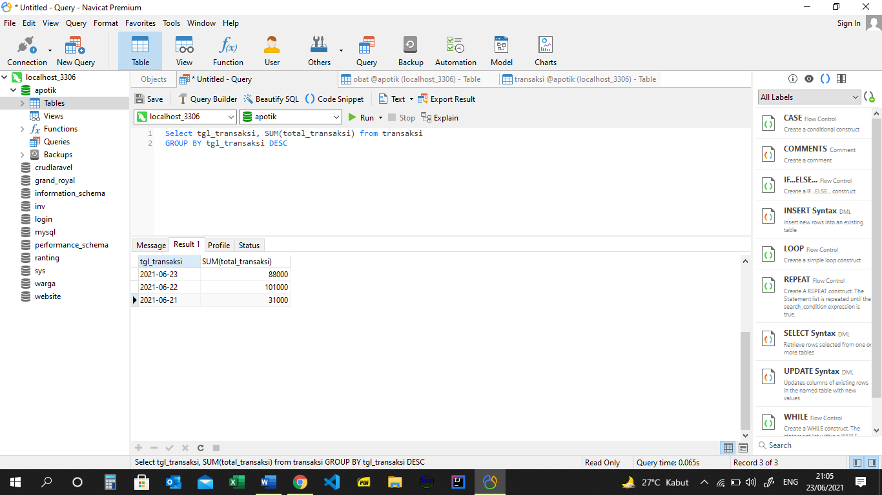

5. Select tgl_transaksi, SUM(total_transaksi) as Total from transaksi GROUP BY tgl_transaksi ASC

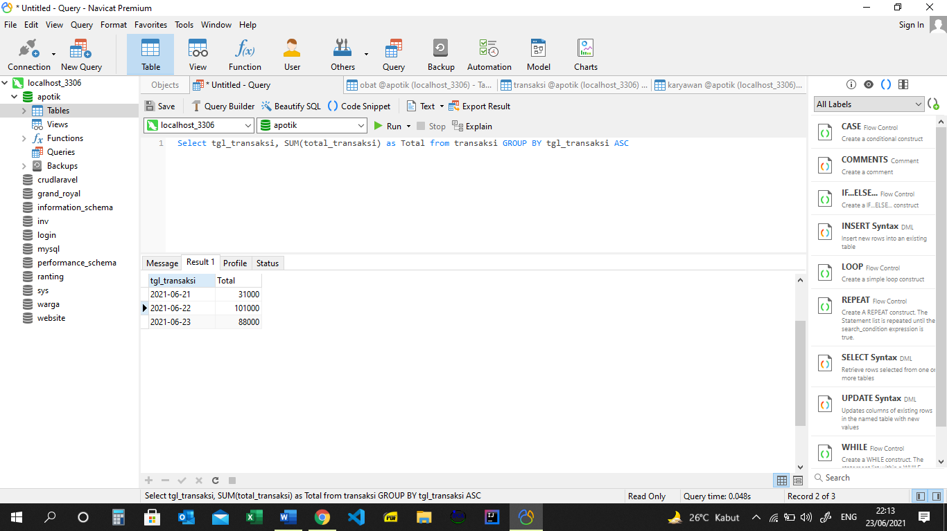

6. Select tgl_transaksi, SUM(total_transaksi) as Total from transaksi WHERE tgl_transaksi > "2021-06-21" GROUP BY tgl_transaksi ASC

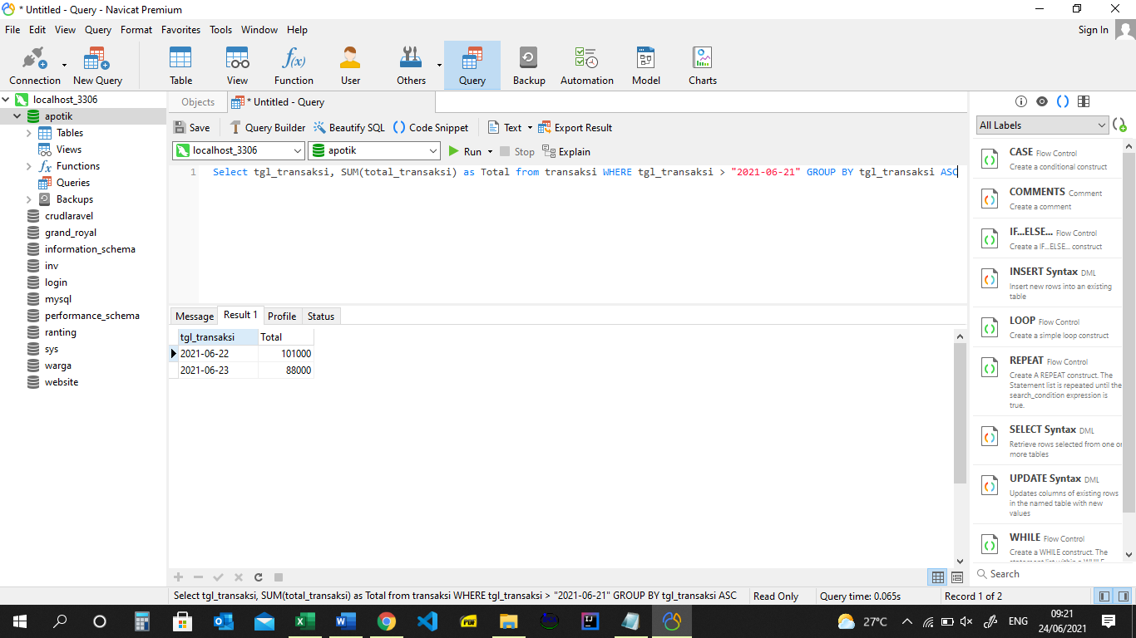

7. Select * from Pemasok where alamat LIKE "%Bekasi%" ORDER BY nama_pemasok asc

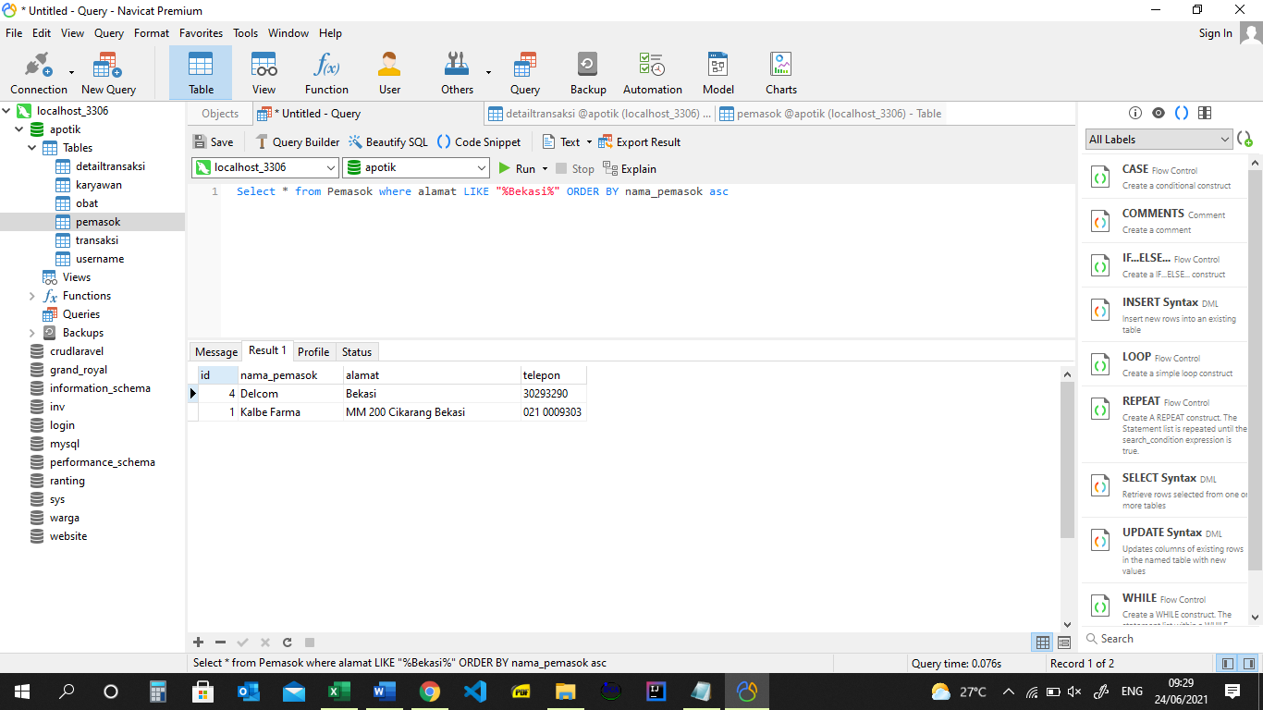

8. SELECT SUM(harga), id_pemasok from obat Where Harga > 5000 GROUP BY id_pemasok ORDER BY id_pemasok ASC

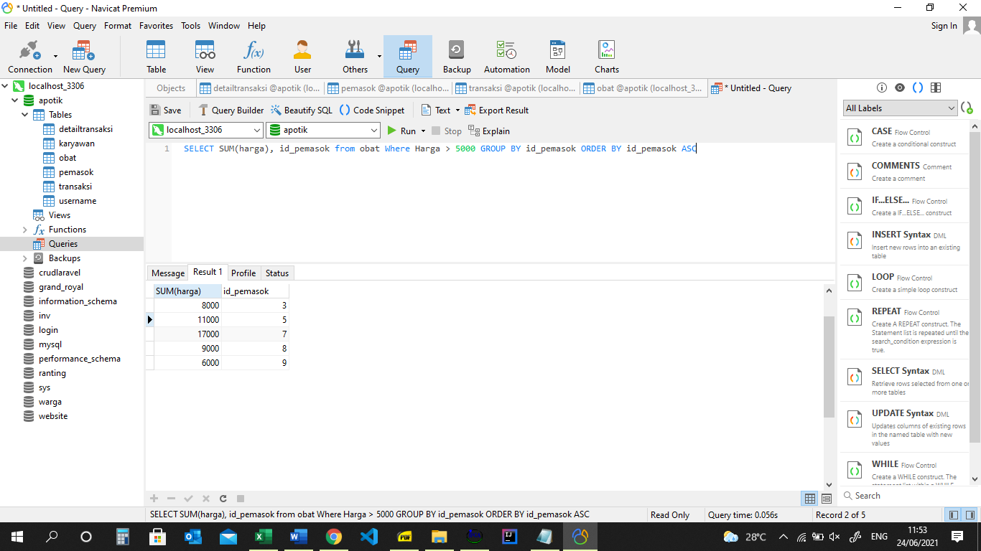

9. SELECT SUM(harga), id_pemasok from obat Where Harga <= 5000 GROUP BY id_pemasok ORDER BY id_pemasok DESC

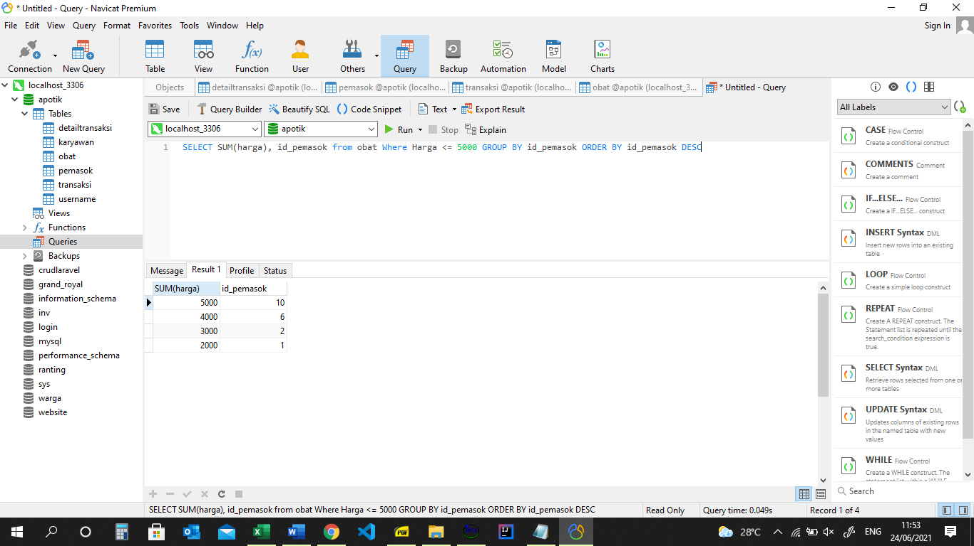

10. Select * , SUM(jumlah * harga) as total from detailtransaksi GROUP BY id ORDER BY id DESC

